

Business Support Professionals

Competency framework for business support providers





This report has been part funded by:

**

|  |  |  |
| --- | --- | --- |
|  | CONTENTS | PAGE |
| **1** | **Executive Summary** | **3** |
| **2** | **List of Tables & Sketches** | **4/5** |
| **3** | **Introduction** | **6** |
| **4** | **Competencies** | **11** |
|  | 1. The definition 2. Classification of competencies 3. How to identify and use competencies |  |
| **5** | 1. **Bloom’s Domains and Organisational Capabilities** | **17** |
|  | 1. Bloom's taxonomy applied 2. Organisational capabilities of business support providers |  |
| **6** | **Evidence of competencies usage** | **20** |
|  | 1. Competency framework in established national qualification standards 2. The use of competency framework by consulting firms |  |
| **7** | **Conclusions & Recommendations** | **25** |
|  |  |  |

**ACKNOWLEDGMENTS**

**A Temple in the Black Country**

This is a community organisation which wasstarted by a group of volunteers in the mid 1990’s, for families who had migrated from India. They set it up so that they could: socialise, get to know each other, help their children with their education, teach their culture and customs to new generations and to take care of their elders. All of the workers contribute untold hours into building and maintaining the organisation.

Researchers at BCU and in the CPU undertook this project funded by the Leonardo European Union Measure project; as one of a series it has published on the subject of Business Support Professionals..

The project is a partnership of public, private and third sector organisations. The collaborative approach between academics and practitioners should be acknowledged as beneficial to all parties; making the research process come alive. The project team would particularly wish to acknowledge that a considerable number of workers in the Business Support Sector contributed to the outcomes. Their contributed of time and expertise, providing the information for this report, was exemplary.

**Vinko Zupančič Phil Rose**

**Institute for Business Education Birmingham City University**

**Executive Summary**

**A Temple in the Black Country**

This is a community organisation which wasstarted by a group of volunteers in the mid 1990’s, for families who had migrated from India. They set it up so that they could: socialise, get to know each other, help their children with their education, teach their culture and customs to new generations and to take care of their elders. All of the workers contribute untold hours into building and maintaining the organisation.

**A Temple in the Black Country**

This is a community organisation which wasstarted by a group of volunteers in the mid 1990’s, for families who had migrated from India. They set it up so that they could: socialise, get to know each other, help their children with their education, teach their culture and customs to new generations and to take care of their elders. All of the workers contribute untold hours into building and maintaining the organisation.

**A Temple in the Black Country**

This is a community organisation which wasstarted by a group of volunteers in the mid 1990’s, for families who had migrated from India. They set it up so that they could: socialise, get to know each other, help their children with their education, teach their culture and customs to new generations and to take care of their elders. All of the workers contribute untold hours into building and maintaining the organisation.

This survey will produce a comparative study of Business Support Agencies across a sample of EEC states; participating in an EU Leonardo Project (see later for details). Across the European Union differing approaches are adopted to deliver enterprise business support. This survey will attempt to map those approaches and draw conclusions from it.

Alongside this survey are two parallel studies. Firstly drawing the Architectural Framework created by nation states that business support fits within. Secondly that is mapping the professional status of Business Support Professionals across the same EU states.

Overall, the research aims to compare these findings with the national data provided and report on business support success in general. Specifically, a correlation between the various findings could give more in-depth insights in indentifying appropriate and successful Business Support. A best practise would inform other business support agencies, across the EU, which will provide implications at both policy and practical level. Moreover, the findings would benefit to other wider interest groups, include business enterprises, researchers and academia in the research fields.

Structurally the report gives the background to the Leonardo Project and its partners – including a small sketch of each partner. This is followed by a brief methodological statement underpinning the research.

The report then turns to the issue of competencies in general terms pointing out that today's post industrial society is witnessing the comeback of competencies. The same is very actual in the field of business support providers.

The overwiev is testing the validity of Bloom’s domain for the business support framework of competencies and finds some interesting applications both on the level of national consultancy organisations as well as with some individual consultancy companies. The case of IMC USA shows the way forward since it was In March 2010 accredited as a ISO/IEC 17024:2003 Certifying Body for the CMC®, Eligibility Standard 1 to form the [IMC USA Competency Framework - Certification Scheme for the Certified Management Consultant™ (CMC®)](http://www.imcusa.org/resource/collection/4B166389-2DB0-4C83-8659-5B5EBCCC4772/IMC_USA_CMC_Competency_Framework_-_Certification_Scheme_Revision_4_on_06_18_2010.pdf),

Another challenging direction of the report is dealing with the role of consulting organisation.

It is possible to distinguish between the competencies of individual consultants and capabilities of consulting firms. Means that the best consulting companies’ scores should have excellent consultants and excellent organisation's capabilities including job requirements.

Finally basic principles of business support competency framework can be otulined together with some recommendation for futher activities.

**Vinko Zupančič Phil Rose**

**Institute for Business Education Birmingham City University**

|  |  |  |
| --- | --- | --- |
|  | **LIST OF TABLES, CHARTS AND IMAGES** | **PAGE** |
| 1 | Political Map of Europe | 7 |
| 2 | Economic Map of Europe | 7 |
| 3 | Partner Employee Profile | 8 |
| 4 | Partners Sector | 8 |
| 5 | Partners Specialisms | 9 |
| 6 | Partnership Role | 9 |
| 7 | Partners Skills & Experience | 10 |
| 8 | Overview of Competency | 11 |
| 9 | Classification of competencies | 12 |
| 10 | American Managers Associations Generic Competency Model | 13 |
| 11 | Description and competency progression for “Change Control” | 14 |
| 12 | An example of the wheel of competencies | 15 |
| 13 | Bloom's taxonomy domains – simplified version | 18 |
| 14 | Zone of competencies - optimal performance in particular job | 18 |
| 15 | UK Competency framework | 20 |
| 16 | Further development of UK Competency framework | 21 |
| 17 | Spanish Qualification Progression – part 1 | 22 |
| 18 | Spanish Qualification Progression – part 2 | 23 |
| 19 | Progression stages in IMC USA Competency Framework | 25 |

***Syntra West***

Syntra West provides specialised training programmes for starting businesses and plays, as such, a determining role in the success rate of starting businesses.

***Retail Business Confederation Of Andalusia***

Representing over 30,000 SME’s and over 68,000 retailers. It supports and promotes “Centros Comerciales Abiertos” (CCA), town centre retail districts, created through the Net of the “Centros Comerciales Abiertos” of the Andalusia.

***European Management Centre***

EMC is working since 2001 in the field of Vocational Education & Training and services offered for SME’s, especially: Strategic Management, Company Development, Modern Marketing and Customer Relationship Management, Cost Efficiency Strategy, Team Motivation & Logistics Management. It supports what has become a rapidly growing movement to underpin global markets with universal principles on human rights, labour standards, environmental sustainability and

anti-corruption practices.

|  |  |  |
| --- | --- | --- |
|  | **THUMBNAIL SKETCHES** | **PAGE** |
| 1 | Belgium: Syntra West | 5 |
| 2 | Bulgaria: European Management Centre | 4 |
| 3 | Norway: City of Oslo, Agency For Business Development | 5 |
| 4 | Slovenia: Chamber of Commerce and Industry of Slovenia Institute for Business Education | 4 |
| 5 | Spain: CECA, Retail Business Confederation Of Andalusia | 4 |
| 6 | United Kingdom: Business Enterprise Support and Birmingham City University Business School | 5 |

***Chamber of Commerce and Industry of Slovenia Institute for Business Education***

Education and training providers for adults; tradition and experience in: development, organisation and implementation of professional and technical seminars, training courses, workshops, short- and long-term courses and other events for the needs of business subjects Slovenia.

***Business Enterprise Support***

BES is a registered enterprise agency. Our core objective is to deliver services through the wider enterprise agenda. This includes enterprise awareness, business start-up, business development and development of the infrastructure including business support professionals. This is delivered by coaching, mentoring, training, advising, qualifications, awards, consultancy and products for delivery, licensing and general commercial sale. Our mission is to ‘Enable an Enterprise Culture’.

***Birmingham City Business School***

The school is an international University providing degree and post graduate qualifications in all business areas. It has a recognised research expertise in enterprise and innovation. The Social Economy Evaluation Bureaux is an internal organisational part of the School.

***City Of Oslo – Agency For Business Development***

The goal of the Agency for Development Division is to make it easier and more attractive for people to set up and run a company in Oslo. The Agency provides free information and advice on how to go about setting up a company. We have a broad range of information brochures from a number of government agencies, as well as some brochures we have compiled ourselves. The Business Development Division can help you find out what rights and duties you have as a business person, and what permits and authorisations you need.

**Introduction**

The theoretical underpinning to this research is the proposition that those working in the business support sector require recognition and status equivalent to their influence in society. Business Support Professionals are agents for change in the economic world, playing a critical role in assisting the creation of wealth in this time of recession.

This report explores the business support work. It defines the profession through the analysis of practitioners in six countries across the European Union and the European Free Trade Federation. No map exists of business support and what constitutes effective delivery; this report attempts to address the balance.

If the profession is to achieve a higher recognition this must be achieved by delineating its achievement and by improving its qualified status; through the creation of business support professional standards, unified purpose and qualified status.

**Business Support Professionals Group**

The BSPCP is a development partnership which aims to promote the creation of a unified business support approach. Membership of the group is self selecting and is made up of a business support agency in six European states; Belgium, Bulgaria, Norway, Slovenia, Spain and the United Kingdom. A thumbnail sketch of each of the partners is elsewhere in this report. A comparative profile has been created that validates the contents of this report. That comparative profile is over the page.

The partnership was formed for the purpose of pan European research under the Leonardo funding programme. The partnership intends to develop its activities to embed the work of the report into the European enterprise culture.

**Defining the Constituency**

The Union has twenty seven states in membership since the expansion in 2007, with a further four in the European zone or trade areas.

The six represented here cover original Union and new member states plus an EFF member.

Population Size of the nations represented herein:

|  |  |
| --- | --- |
| Country | Population |
| Belgium | 10.7 million |
| Bulgaria | 7.6 million |
| Norway | 4.8 million |
| Slovenia | 1.9 million |
| Spain | 45.7 million |
| UK | 70 million |

**Maps of the Union areas:**

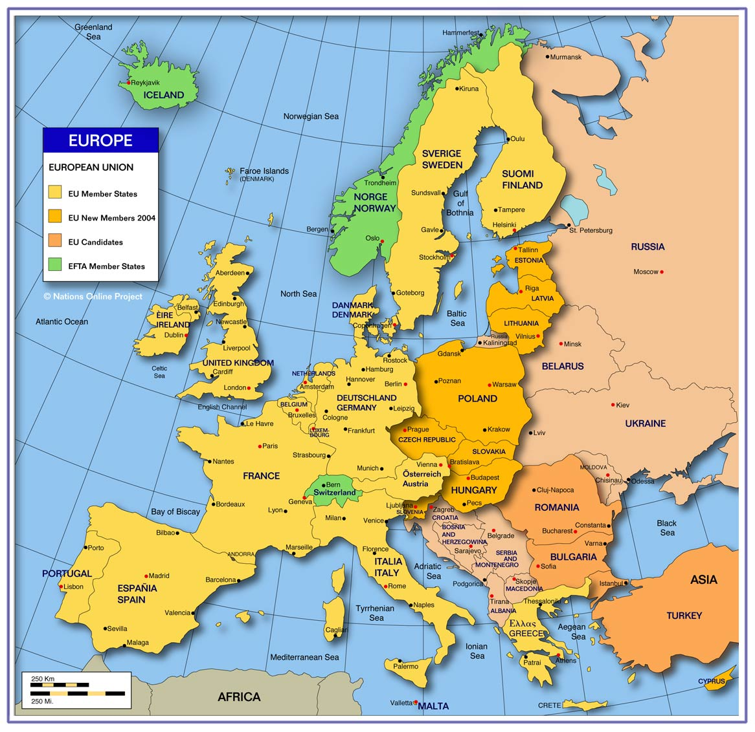

Table 1: Political Map of Europe

**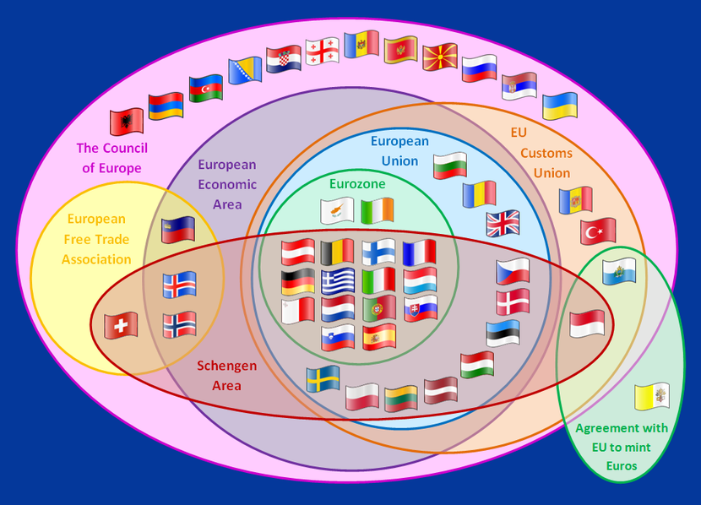**

Table 2: Economic Map of Europe

**Partnership Profile**

This inchoate Leonardo partnership is atypical of the business support arrangements across Europe. None of the members have participated in a European project together before. The major variation within BSPCP is the size and scope of each organisation and whether is supports all sectors in its nation’s economy or just one or two.

Table 3: Partner Employee Profile

As can be seen by the chart above all of the organisations would be defined as small, using European bench marks, with the one exception which is a medium size business; the University being large. This typifies the profession as a low volume high specification business.

This chart shows that the overwhelming majority of partners operate within the not for profit sector, with public sector backing and funding. The private sector is not represented within this project and does not feature significantly in the business support sector across the EU.

Table 4: Partners Sector

**General Description**

Each partner brings a distinctive description of their operation to the project. As can be seen from the graph below there is a common theme to all the partners: the knowledge and the skills development of individuals; increasing economic activity in addition to the obvious involvement in business support.

**Specialisms’**

The Partnership, between all the members, encompasses all of the principal business support specialisms; as can be seen from the following chart:

Table 5. Partners Specialisms

This span of specialisms enables the partnership to speak with authority on the Business Support Profession. Collected together within the partnership are public sector workers deliberating in an objective manner whilst the remainder are practitioners from a not-for-profit perspective. This profile gives the research activity and findings legitimacy and validity.

**Partnership Role**

Each of the partners has a clear primary responsibility within the project; plus a secondary role.

|  |  |  |  |  |  |  |  |
| --- | --- | --- | --- | --- | --- | --- | --- |
|  | Partner | | | | | | |
| Role | SW | EMC | CDU | IBE | CECA | BES | BCU |
| Managing partnership |  |  |  |  |  | ✓ |  |
| Exchange of experience | ✓ |  |  |  |  |  |  |
| Coordination of Benchmarking |  |  |  | ✓ |  |  |  |
| Develop the Qualification Matrix |  |  | ✓ |  |  |  |  |
| Evaluation |  |  |  |  | ✓ |  |  |
| Dissemination |  | ✓ |  |  |  |  |  |
| Research |  |  |  |  |  |  | ✓ |

Table 6: Partnership Role

**Key Skills and Expertise**

When joining the partnership the self elected members offered a range of skills and experience that is vital to the project. The self experienced skills and experience that are embedded within the partnership looks like this:

|  |  |  |  |  |
| --- | --- | --- | --- | --- |
|  | Skills and Experience | | | |
| **Management** | **Education and**  **Training** | **EU Projects** | **Research** |
| Belgium | ✓ | ✓ | ✓ |  |
| Bulgaria | ✓ | ✓ | ✓ |  |
| Norway | ✓ |  |  |  |
| Slovenia | ✓ | ✓ | ✓ | ✓ |
| Spain |  | ✓ | ✓ |  |
| UK | ✓ | ✓ | ✓ | ✓ |

Table 7: Partners Skills & Experience

Each of the partners has a single lead staff member representing their parent organisation. These single lead members are supported by up to four other staff members from their host organisation. No partner has a trainee as a member of its mobility team.

All partner staff status is supported by their qualification to participate in the project. This qualification is either by the prior achievement of a recognised education award or by significant experience in the business support profession.

There does not exist a map of the qualifying status for the profession of business support therefore benchmarking the partners against a set of recognisable standards is not possible. This is of cause one of the principle reason why the partnership was created. Emerging out of the partnership – and beyond – should be a recognisable benchmark set of standards to measure the profession, at least across Europe.

**Knowledge Gathering**

A cornerstone of project activity was an exchange of experience event in each of the member’s state/organisation. These six events provided the partnership with considerable insight into the business support activity operating within the public realm. At each event typically would receive presentation from experts in the host nation and an examination of the business support architecture. This enabled the research to have a qualitative and textural feel to its work; reflected in the findings later in this report.

**4. Competencies**

## The Definition

Historically competencies were well integrated into craftsmen work. One was able to progress from apprentice to master level by gradually learning and mastering the skills in line with the craft in question. After passing master exam he became a master. Industrial era brought simplification of work and decreased the need for qualification together with extensive use of assembly line technology. Today's post industrial society is witnessing the comeback of competencies.

Competencies are not authorisations, mandates or power. They are *(Perrenoud, 1997) “capabilities of an individual to activate, use and integrate the acquired knowledge in complex, diverse and unpredictable situations*.” Competencies are the way we do the job (New, 1996: p. 449).

Source: Kohont, Andrej. Competency profile of Slovenian experts for human resources management, master thesis, University in Ljubljana, Faculty for social sciences, Ljubljana, 2005

Table 8: Overview of Competency

It is not the knowledge itself that counts, but its application (Eurydice, 2002). We tend to develop competencies as an upgrade of written knowledge. Scholars first delimited the terms knowledge and competence. They state different sorts of knowledge (explicit and implicit/tacit knowledge) pointing out, that explicit knowledge (information) is usually connected with particular science areas while implicit knowledge is usually manifested through transversal, personal and social competencies (Key competencies, 2002). The need for memorizing the facts (declarative knowledge) is decreasing while their scope constantly increases. This leads to an increase of mastering of instruments/tools/procedures to select, process and use of information. For this type of knowledge the term »competencies« has been introduced.

In line with abovementioned, competencies could be described as procedural and strategic knowledge. Romainville (1996, ibidem, 13) mentioned, that this word, apparently of French origin, was first used in vocational training in terms of »ability to do particular job or task«. Only earlier competency appears in general education field describing capacity to use particular knowledge.

## Classification Of Competencies

The focus of attention is to the description and defining the individual competencies; with the needs and requirements of those of the organisation. This matter is dealt with later. Individual competencies can be tabulated as these:

****

Source: Kohont, Andrej. Multilayerage and usefulness of competencies. University of Ljubljana, Faculty of social sciences,2009

Table 9: Classification of competencies

This table displays the many facets of competencies are first shown through a division down to the sorts of competencies that are required for task completion. These can be delineated as follows:

**Key, Threshold or Generic Competencies**

They competencies are transferrable between working tasks (for all humans): reading and calculating literacy, communication in a mother tongue, personal and social-interpersonal characteristics, information and communication technology usage, foreign languages, scientific literacy and entrepreneurship. These competencies can contribute to the welfare of all society members. They all correspond to normative and societal values and constitute the bedrock of a civic society and the inter-relationships between all members of all societies. In the business contex they are demonstrably the basic skills for conducting trade and commerce.

**Work Specific Competencies.**

Work specific competencies are aspects of activities that are particular to a working role; connected to its performance. They are attributes necessary to successfully perform particular job or work task. They are common for particular working areas or groups of workplaces: communication, problem solving, logical inference, leading, creativity, motivation, team working, and ability of learning. We know that workers in the financial sector require specialist competency to trade finance, marketers, sales representatives, developers and so on. Thus business support providers require a set of competencies that enable successful performance of their role in the economic structure.

**Organisational Specific Competencies.**

These competencies are the means with which an individual worker can adapt their way of responding to the organisational culture; regardless the actual job being performed. This competency is a response to the need for a culture that derives from the company’s mission, its values and the organisational strategy. Bound together are the individuals into the organisation and to their functions and roles in fulfilment of the mission. Organisational specific competencies are connected with efficiency of individual in organisation as a whole.

**Managerial Competencies**

Described as the ability of managers to efficiently use knowledge and experiences in performing the managerial role and capability of forming a system or series of behaviours that lead the manager to attain particular goal that are set (Constable, 1988 In Jackson, 2002). A tabulated form of the managerial competencies has been drawn by the USA Managers Association:

|  |  |  |
| --- | --- | --- |
|  | Competency | Descrition |
| A | **Goal And Action Orientation** | Goals and priorities setting, efficiency, pro-activity, consequences investigation, diagnostic use of concepts, focus on business excellency, tracking changes, reaction to (unexpected) changes. |
| B | **Co-Workers Guidance** | Use of power, co-workers development, spontaneousness. |
| C | **Human Resources Management** | Realistic self-evaluation, self-control, resistance and adaptability, realistic perception, positive approach, sensibility for needs of others, establishing confidence in other people, group management, social power. |
| D | **Leadership** | Self-confidence, logic and conceptual thinking, communication. |

Source: Jackson, T.: The competent organisation: The American model. In: Jackson, T., International HRM: A cross-cultural approach. London: Sage Publications, 2002. p. 65

Table 10: American Managers Associations Generic Competency Model

This is an expert opinion that concludes that a managers today are much more akin to the role of a consultant than as a chief officer; as was the norm in the past. Consecutively the well developed existing managers’ competency profiles or systems could be adapted for use in BSP context of BSPCP project.

In addition to these divisions of competency further study finds some other useful classifications of competencies with variety of viewpoints are shown below:

**Expected competencies**

These are those that are expected from society (key competencies respectively) or from an organisation for the efficient performance of tasks or roles execution (in this case they are work and organisational specific competencies).

**Actual and potential competencies**

Actual are possessed by individuals enabling them to be successful in the performance of societal and organisational tasks and roles; while potential competencies are those still in the development phase of individual based on his predispositions. The former can be measured and described, the later are more intangible and their development can be more or less successfully predicted.

It could be a challenge for BSP competency framework to be able to find out a state of the art of potential competencies with particular BSP specialist.

**Described and progressive competencies**

Competencies description is used in organisations or elsewhere (e.g. in education) and shows a picture of the organisation or in the respective organisation employed people have about particular competency. It is wording of competency definition within organisational culture.

Organisational competencies of individuals are shown in intervals thus defining efficiency of individual when performing tasks and roles. A competency level (level of particular competency) enables the organisation to differentiate between individuals (differentiation competencies) and can be in variety of ways used in HRM system, giving the individual feed back information about his competency as well. This system of progression can be exemplified in this chart describing the competency of controlling change:

|  |  |
| --- | --- |
| Control changes |  |
| Description: | Self-initiative acquiring of new knowledge, initiative taking and receiving for innovations and their integration in his own work within the working environment. |
| Stages: | 1. Mastering the basics, minimal standards, 2. Mastering normal situations 3. Mastering changing situation and innovation 4. Transferring the knowledge to others |

Adapted from: Kohont, Andrej. Competency profile of Slovenian experts for human resources management, master thesis, University in Ljubljana, Faculty for social sciences, Ljubljana, 2005

Table 11: Description and competency progression for “Change Control”

Any layout of a BSP competency framework will heavily depend upon the progression of competencies in line with the adoption of Bloom's domains of taxonomies; for differentiation of the sorts of knowledge. In comparison with some established national consultant competency frameworks and certification schemes is this clearly a point of differentiation (and potential challenge in measuring the stages). How can these competencies be made accessible and visible?

**Competency Visibility**

From the visibility viewpoint the competencies can be divided onto:

* Visible competencies (e.g. knowledge, routine, skills) which could be relatively easily developed through education and training and,
* Invisible or hidden competencies (e.g. characteristics, behaviour, values, beliefs) which are not easily developed through education. It is much easier to “choose the right people to the right places”

To enable the accessibility, we can turn to the work on imaging the competencies through the creation of a wheel picturing them.

**The Wheel of Competency**

The so called wheel of competencies is often the final outcome of competencies classification in an organisation, encompassing all of them, being important for the company development.



Source: Kohont, Andrej. Multilayerage and usefulness of competencies. University of Ljubljana, Faculty of social sciences,2009

Table 12: An example of the wheel of competencies

A similar wheel of competencies, in its graphical descriptive layout, could be used to show a final outcome of competencies that a BSP specialist needs to posses and develop; in order to obtain the necessary competencies dimension. All of this means that we need to answer the question: what competencies are needed?

## How To Identify And Use Competencies

Several approaches to the identification and usage of competencies have been published and are therefore available for application available (Kohont, 2003, p. 50):

* **American** (McBeer, McClelland, Boyatzis). Competencies are the characteristics of individual connected to superior performance. The role of “top performers” is heavily stressed.
* **French** (Levy-Leboyer). Competence is a set of different psychological elements (capacities, personal characteristics, motives, knowledge) of an individual. Self-image forms the foundation.
* **British** approach is the result of activities of two bodies: Management Charter Initiative – MCI and National Council for Vocational Qualifications - NCVQ. Resulting from work tasks. The goal for MCI is to define the standards of managerial competencies and then the later to use together with NCVQ in vocational training and certification. Vocational competency is capacity of performing particular profession according to the standards of employment (Civelli, 1997, p. 227). While competency is measure of the education process output. Activities to be performed by an individual in the organisation need to be identified and then competencies are developed by the help of vocational system.

Identifying the levels of required competencies is a job in interaction with those who know a particular job the best or is being even performed by them. Some organisations are too fast in adopting general accessible competence catalogues.

After having a look to different approaches in identifying and using competencies much of the established benchmarking task within BSPCP project is clearer. Now to better understand the background of the focus on education and training as a single source of competencies. Measurement of the formal education or so called cognitive knowledge is also not a problem. The problem arises with wide spreading the framework to all three Bloom's domains as well as organisational competencies. Formal knowledge is learned and easily measurable, skills have to be learned, but on the field and their measurement is more complex including real situation cases. Values stem from social environment, personality and working environment at least and are real challenge to be measured. The evidence from theory confirms a necessity to use wider approach what will be also dealt with comparative analysis of different existing practices with competency frameworks below.

A variety of methods for assessing competencies exists. Some elements to consider the competencies assessment encompass:

* Expert logic: assessment is being made by excellent workers, experts, managers, technologists or competencies tutor from HRM department by workshops, individual work, task analysis
* Excellent workers: self-observation, behavioural interview
* Behavioural patterns: critical events, annual interview
* Adapted generic models: foreign patterns
* Analysis of strategic company documents
* 360°  approach

It may have sense for the project in question to adopt appropriate managerial framework of competencies and/or existing consultants competency frameworks (method of adapted generic models) as already mentioned, understood as a starting point which could later face refinement and exactness in terms of business support industry specifics. This also means additional use some of other above mentioned methods.

Competencies are usually used for the following areas:

* Education: achieving levels, raising levels of knowledge, adding competencies
* Work description: expected competencies of a worker
* HRM: competencies examination
* Introducing to work: promoting expected competencies
* Career development: long term harmonisation of expected and existing competencies
* Rewarding of competencies
* Managing: new role of managers

Much of these is built in the proposal for competency framework for “business support providers”.

**5. Bloom’s domains and** **organisational Capabilities**

# 

# a) Bloom’s Domains and Question of Organisational Capabilities of BSP

Initial input to the project task was the notion of “Benchmarking” the BSP was the central idea that business support provider is climbing the “Bloom’s” ladder over his career; consisting of different levels of mastering the business support job. Applying Bloom's taxonomy was adopted as the appropriate frame.

Bloom's Taxonomy was primarily created for academic usage; however it is relevant to all types of learning.It fits with the dimension of progressive competencies and described those competencies according to increasing weight through incremental levels of description.

Interestingly, at the outset, Bloom believed that education should focus on 'mastery' of subjects and the promotion of higher forms of thinking, rather than a utilitarian approach to simply transferring facts. Bloom demonstrated decades ago that most teaching tended to be focused on fact-transfer and information recall - the lowest level of training - rather than true meaningful personal development, and this remains a central challenge for educators and trainers in modern times. Much corporate training is also limited to non-participative, unfeeling knowledge-transfer, (all those stultifying boring power point presentations...), which is reason alone to consider the breadth and depth approach exemplified in Bloom's model.

Bloom's Taxonomy model is in three parts, or 'overlapping domains'. Again, Bloom used rather academic language, but the meanings are simple to understand:

* **Cognitive domain** (intellectual capability, i.e., knowledge, or 'think')
* **Affective domain** (feelings, emotions and behaviour, i.e., attitude, or 'feel')
* **Psychomotor domain** (manual and physical skills, i.e., skills, or 'do')

In each of the three domains Bloom's Taxonomy is based on the premise that the categories are ordered in degree of difficulty. An important premise of Bloom's Taxonomy is that each category (or 'level') must be mastered before progressing to the next. As such the categories within each domain are levels of learning development, and these levels increase in difficulty.

The simple matrix structure enables a checklist or template to be constructed for the design of learning programmes, training courses, lesson plans, etc. Effective learning - especially in organisations, where training is to be converted into organisational results - should arguably cover all the levels of each of the domains, where relevant to the situation and the learner.

The learner should benefit from development of knowledge and intellect (Cognitive Domain); attitude and beliefs (Affective Domain); and the ability to put physical and bodily skills into effect - to act (Psychomotor Domain).

Here drawn over the page is a really simple adapted 'at-a-glance' representation of Bloom's Taxonomy. The definitions are intended to be simple modern day language, to assist explanation and understanding. This simple overview can help us to understand and explain the taxonomy. The descriptors have been adapted for the business support professional to ease usage.

|  |  |  |  |  |
| --- | --- | --- | --- | --- |
| Cognitive |  | Affective |  | Psychomotor |
| Knowledge | **Attitude** | **Skills** |
| 1. Recall data | 1.Receive (awareness) | 1.Imitation (copy) |
| 2. Understand | 2.Respond (react) | 2.Manipulation (follow instructions) |
| 3. Apply (use) | 3.Value (understand and act) | 3.Develop Precision |
| 4.Analyse (structure/elements) | 4.Organise personal value system | 4.Articulation (combine, integrate related skills) |
| 5.Synthesise (create/build) | 5. Internalise value system (adopt behaviour) | 5.Naturalisation (automate, become expert) |
| 6. Evaluate (assess, judge in relational terms) |  |  |

(Detail of Bloom's Taxonomy Domains:['Cognitive Domain'](http://www.businessballs.com/bloomstaxonomyoflearningdomains.htm#bloom's cognitive domain) **-** ['Affective Domain'](http://www.businessballs.com/bloomstaxonomyoflearningdomains.htm#bloom's affective domain) **-** ['Psychomotor Domain'](http://www.businessballs.com/bloomstaxonomyoflearningdomains.htm#bloom's psychomotor domain)**).** Source**:** <http://www.businessballs.com/bloomstaxonomyoflearningdomains.htm>

Table 13: Bloom's taxonomy domains – simplified version

For the viewpoint of easy use this report paper is going to propose five stages only. In this case the stage 5 and 6 of cognitive domain could be joined as new stage five. Starting the report within BSPCP project focused on cognitive domain only. After getting insight in the conceptual framework regarding individual competencies it is necessary to summarise that all different kinds of knowledge need to be observed in preparing solid competency framework.

Bloom's taxonomy contributes progression layers to BSP competencies framework and clarifies further its content, means the sorts of competencies needed by business support provider.

**b) Organisational capabilities of business support providers**

It is possible to distinguish between the competencies of individual consultants and capabilities of consulting firms. Means that the best consulting companies’ scores should have excellent consultants and excellent organisation's capabilities including job requirements (Hale, 1998). The Venn diagram below outlines their interrelation:

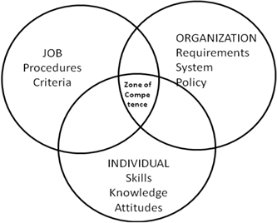

Source: Hale, Judith. The Performance Consultant's Fieldbook. Jossey-Bass/Pfeiffer, San Francisco, 1998, p. 97

Table 14: Zone of competencies - optimal performance in particular job

The quadrant titles INDIVIDUAL represents the three Bloom's domains of taxonomies. Simply, company have to have competent consultants. Different people bring different skills, knowledge, emotional and physical capacities, and motives to their job. Their performance can be enhanced or threatened when there are changes in their capacity (intellectual, physical, or emotional) or personal motives.

Perhaps it has sense to merge JOB and ORGANISATION, thus giving the influence of working environment (consulting organisation he is working for) for consultants. We could understand then that sole consultant (even as legal entity) is not that successful than well organised and resourceful consulting organisation.

People performance depends on what the organisation can offer. No matter its size, an organisation shapes what its people do and how they do it. Organisations shape performance through their culture and values, their leadership and guidance, their information systems their core competencies and technologies, their product mix and customer profiles, their economic strength, and their reputation on the marketplace (Hale, 1998, p. 97).

Competence actually depends on three factors: particular situation, individual and organisation. It is practical sense displayed through actions by individuals in a organisational context, which (actions) in the same context are deemed competent by the community (ies) of practise in which the activity is taking place (Bramming, Holt Larsen, 2000, p. 79).

Organisational competence is a whole of different technological capabilities, complementary material resources and organisational routines that form basic comparative advantage in one or more organisations (Dosi et al., 2000, p. 3). These and other definitions often describe organisational competencies as knowledge and capacities, being collectively learned in the organisation enabling it to act differently from the competitors.

An expert opinion points out that organisation is not having competencies; competencies are strictly bound to the individual. Organisation is able to develop expectations towards a prospect or employed person in a way of job description. Organisation can heavily support individual performance with established systems, policy and strategy setting and other sources, what is normally recognised as capabilities of organisation. The fact is, that some literature about competencies uses and connects the term competencies with organisation, too. To sort this difference out let's bear in mind above-mentioned and take any mentioning of competencies in the organisational context in terms of their capabilities.

Organisational competencies (capabilities) are often divided into organisational specific and key competencies. Organisational specific competencies (New, 1996, p. 45) are defined as goals according to which an individual in organisation coordinate his performance within organisational culture, regardless the role he is performing. Organisational specific competencies are tied with efficiency of an individual in the organisation as a whole. Organisational competencies are tightly bound to individual competencies. From the viewpoint of an individual, organisational competencies can be defined as key competencies that are expected from him in the organisation. In this way organisational specific competencies become a part of key/threshold individual competencies within organisation.

Authors differently understand key organisational competencies. They are connected with differentiation ability, thus producing comparative advantage for organisation (Andrews, 1971 In: Hauser et al., 2003) They are also a capability of an organisation when three criteria are met: (1) produce value for customer, (2) enable differentiation among rivals, (3) enable extendibility (Prahalad and Hamel, 1994, p. 223) .

Some authors contributed term generic organisational competencies. The later can be grouped as follows (Thompson In: Cole, 1997, p. 18): strategic awareness, meeting the needs of customers/stakeholders, competitive strategy, strategy implementation and change, quality and customer concern, functional competencies, avoiding failures and crisis, ethics and social responsibility. This grouping is actually a set of 32 generic organisational competencies as mentioned by the same source.

Approaches to organisational competencies are rather different. To get somehow a big picture framed I would take generic competencies as core competencies according to the Hale's opinion. In this way we can integrate Hale's organisational influence with set of generic competencies what gives us fairly clear notion of organisational competencies (capabilities) to be used within the BSP competency framework.

1. **Evidence Of Competencies Usage**
2. **Competency framework in established national qualification standards**

**The case of UK**

The project found some examples of application by nation states of a framework applied. The first of these is from the UK and is summarised below:

|  |  |  |  |  |
| --- | --- | --- | --- | --- |
| Job Role | Level | Licensed | Accredited | Development and Delivery Criteria |
| **Community Enterprise Champion** | 2 | No official requirement to date | No | Training Modules and Assessment |
| **Enterprise Coaches** | 3 | Community Enterprise Engagement contractors. | No | Training Modules Observations, Assessments, Shadowing, assignments |
| **Enterprise Advisers** | 4 | Business Link requirement in some regions and potential skills brokers | Yes | Training Modules Observations, Assessments, |
| **Business Advice Brokers** | 5 | Mixed dependent upon region policy | Yes | Assessment Centre’s, Development Centre’s, Self-assessments, Training Modules Observations, Assessments, Shadowing, assignments |
| **Professional Adviser** | 6 | No | In Progress | Training Modules Observations, Assessments, Shadowing, assignments |
| Business Consultant | 7 | No | No | Modular Delivery, lectures, assignments, dissertation |

Sources BES (2010)

Table 15: UK Competency framework

This approach demonstrates an emerging strategy for developing a competency framework and the link to qualification framework needed to certify the competency. The applying of the taxonomy and the qualifications needs improvement.

Further development is highlighted below serving simultaneously as basic principles outline towards future business support competency framework.

Sources BES (2010)

Table 16: Further development of UK Competency framework

**The case of Spain**

The second example is the Spanish experience. This is separated into the Public and Private domains. This is demonstrably different from the UK experience it could represent the mainstream continental European approach to qualifications standards that can be applied to BSP’s.

The first part is the Public domain the second the private:

|  |
| --- |
| **PUBLIC MATRIX**  Government employee C1- Level of qualification 2 (Spain) or 4 (Europe)  Government employee A1 – Level of qualification 5 (Spain) or 7 (Europe)  Government employee A2 – Level of qualification 4 (Spain) or 6 (Europe)  Government employee B – Level of qualification 3 (Spain) or 5 (Europe)  Government employee C2- Level of qualification 1 (Spain) or 2 (Europe) |

Source CECA (2010)

Table 17: Spanish Qualification Progression – part 1

|  |
| --- |
| **PRIVATE MATRIX**  In this part, the matrix is different depending on the sector. In this way, in case of commerce we have the following matrix:  IV PROFFESIONAL GROUP (Professional Office, Assistant Box 2nd, Assistant Safety 1st, Administrative Assistant, Administrative, Dependent 2nd, 1st-dependent, route accounting business travelers, window dressing…) -Level of qualification 2 (Spain ) or 4-3 (Europe)  III PROFFESIONAL GROUP (Head of Commercial Section, Cashier, Officer Administrative, Chief Workshop, Manager of Establishment…) - Level of qualification 4 -3 (Spain) or 6- 5 (Europe)  II PROFFESIONAL GROUP (Accounting, Administrative Section Chief, General Manager and Store Manager…) - Level of qualification 5-4 (Spain) or 7-6 (Europe)  I PROFFESIONAL GROUP (Director, Division Chief, Chief of Staff, Head of Purchasing Head of Sales…) - Level of qualification 5 (Spain) or 7 (Europe)  V PROFFESIONAL GROUP (Telephone operator, packer, stock boy, Assistant Mounting, Vigilante, Order, Concierge, 1st Cleaner, Cleaner and Assistant cleaning Mounting, Vigilante, Order, Concierge, 1st Cleaner, Cleaner and Assistant…) - Level of qualification 1 (Spain ) or 2-1 (Europe) |

Source CECA (2010)

Table 18: Spanish Qualification Progression – part 2

**The case of USA**

The third example is an American one.

*Management consultants are those organizations and/or individuals that participate in the process of management consulting within a framework of appropriate and relevant professional disciplines and ethics designed for the activity of management consulting."*  
Source: Institute of Management Consultancy, definition in self-regulation paper (the Institute of Management Consultancy, the UK equivalent of IMC USA, merged in April 2007 with the Institute of Business Advisers to form the Institute of Business Consulting)

The IMC USA Management Consulting Competency Framework defines those competencies required to be a successful management consultant. The competences are the behaviors, skills, and knowledge that a management consultant is expected to understand, apply, and demonstrate. IMC USA's Competency Framework is built upon the Common Body of Knowledge and the core competencies described in this document, both of which are aligned with ICMCI's requirements for reciprocity of the CMC with other affiliated IMC organizations.

An effective Management Consultant requires a balance of behaviors, skills and knowledge:

* **Market Knowledge & Capability**: This is the application of fact-based knowledge of technical skills, business understanding, sector insight, and external awareness.
* **Consulting Competencies:** These are the core consultancy skills, tools, and techniques which are essential in delivering consulting services.
* **Consulting Skills and Behaviours, and Ethics**: These define the professional skills, behaviours, and attitudes which act as "enablers" in achieving market capability, knowledge and Consulting Competence. They establish the level of credibility and trust between the client and the consultant.

The successful management consultant requires a combination of skills, and provides strategic and tactical solutions to a client. These include:

* Change management skills
* Technical and business knowledge
* Business understanding
* Ownership, management and delivery of solutions to clients
* Project delivery and risk management
* Interpersonal skills
* Ability to transfer skills to others
* Creative and analytical thinking
* Adherence to a code of conduct and ethical guidelines

There is also an evidence of progression shown in the table on the next page.

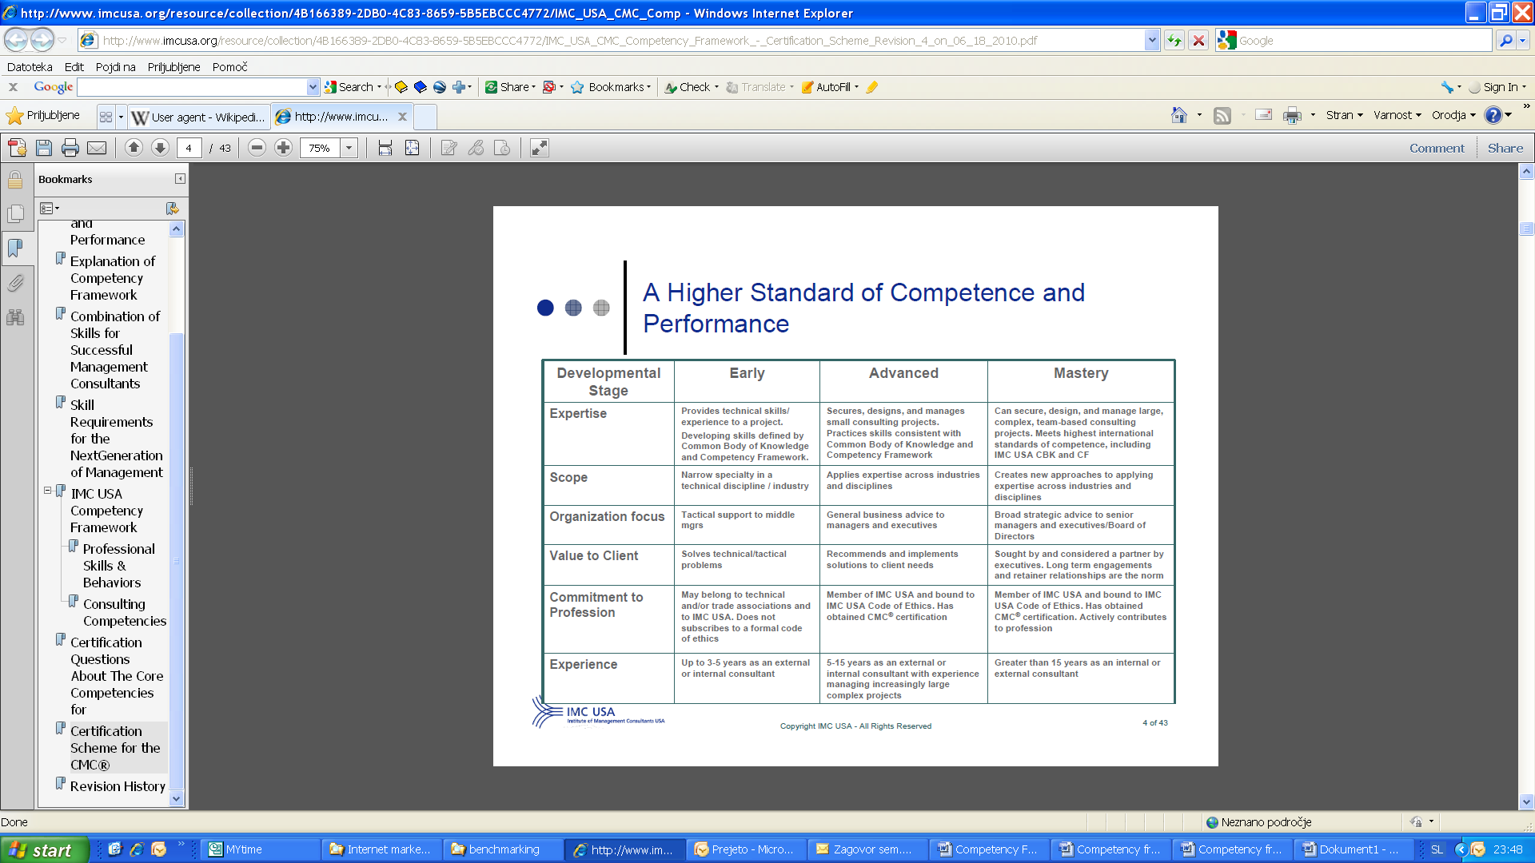Source: http://www.imcusa.org/resource/collection/

Table 19: Progression stages in IMC USA Competency Framework

IMC USA produced competence framework through the work both its members and those of the Institute of Management Consultancy (UK), upon whose work this example is based.

1. **Conclusions & Recommendations**
2. Further develop Competency framework and bring the UK system
3. Develop EU Competency framework in harmony with the most member states
4. Pilot approach in a number of states
5. Look how business support may be developing towards more presonalised coaching and soft skills

**Bibliography**

**Literature**

Bramming, P., Holt, Larsen, H.: Making sense of the drive for competence. In Brewster,

Larsen, H (ur.).: Human resource management in Northern Europe: Trends, dilemmas and strategy. UK: Blackwell publishers, p. 66 – 88, 2000

Day, Christopher (1999). *Developing Teachers, The Challenges of Lifelong Learning*. London:

*Defining competencies and curriculum*, European reference points for the teaching profession,

*Definition and Selection of Competencies* (DESECO): Theoretical and Conceptual Foundations,

Falmer Press.

Hale, Judith. The Performance Consultant's Field book. Jossey-Bass/Pfeiffer, San Francisco, 1998

Jackson, T.: The competent organisation: The American model. In: Jackson, T., International HRM: A cross-cultural approach. London: Sage Publications, 2002

Kohont, Andrej. Competency profile of Slovenian experts for human resources management, master thesis, University in Ljubljana, Faculty for social sciences, Ljubljana, 2005

Kohont, Andrej. Multilayerage and usefulness of competencies. University of Ljubljana, Faculty of social sciences, 2009

New, G.: A three-tier model of organisational competence, Journal of Managerial Psychology, 11 (8): 44 – 51, 1996

Razdevšek-Pučko, C., Taštanoska, A. in Plevnik, T. (2003): *Kakovost izobraževanja s poudarkom naizobraževanju učiteljev in ostalih izobraževalcev*. Predavanje na konferenci (8.10.2003) "Slovenija inskupni evropski cilji na področju izobraževanja in usposabljanja". Ljubljana: CMEPIUS.

**Sources:**

*Key Competencies* (2002). Survey 5. Brussels: Eurydice, European Unit.

<http://www.imcusa.org/resource/collection/>

<http://www.businessballs.com/bloomstaxonomyoflearningdomains.htm>

OECD, DEELSA/ED/CERI/CD (2002)9 Prepared by Eurydice for study visit (England, April 2003).

|  |
| --- |
| untitledParticipating Organisations:  Business Support Professionals  N:\Documents\Business Support Professionals\logo's\BSPLogo.gif  Competency framework for business support providers  © BCU 2010  BES New.PNG  SyntraWest-logo.jpg  LOGO EMC.jpg  CityofOslo.jpg  untitled  **.cpu_logo_test1**  This report has been part funded by:  logo_Leonardo620.jpg  BCU logo 600x600 |