Business Support Professionals

European Business Support Providers Survey: results from six countries, mapping what they do, where and how.

This report has been part funded by:

 | CONTENTS | PAGE
1 | Acknowledgments | 2
2 | Executive Summary | 3
3 | Tables and Charts | 4
4 | Introduction | 6
5 | Leonardo Partnership Profile | 8
6 | Methodology | 11
7 | Towns Participating | 13
8 | Profile of Business Support Agencies | 14
9 | Support Type | 18
10 | Coverage of the Support | 24
11 | Conclusions and Recommendations | 25

A Temple in the Black Country
This is a community organisation which was started by a group of volunteers in the mid 1990’s, for families who had migrated from India. They set it up so that they could: socialise, get to know each other, help their children with their education, teach their culture and customs to new generations and to take care of their elders. All of the workers contribute untold hours into building and maintaining the organisation.

ACKNOWLEDGMENTS

Researchers in the Social Economy Evaluation Bureau at Birmingham City University undertook this project funded by the Leonardo EU Measure.

The invaluable support and encouragement from Cindy Millman and Professor John Sparrow were crucial in this report.

The project is a partnership of public, private and third sector organisations. The collaborative approach between academics and practitioners should be acknowledged as beneficial to all parties; making the research process come alive. The project team would particularly wish to acknowledge that a considerable number of workers in the Business Support Sector contributed to the outcomes. Their contributed of time and expertise, providing the information for this report, was exemplary.

Phil Rose

Birmingham City University 2011
Executive Summary
A Temple in the Black Country
This is a community organisation which was started by a group of volunteers in the mid 1990’s, for families who had migrated from India. They set it up so that they could: socialise, get to know each other, help their children with their education, teach their culture and customs to new generations and to take care of their elders. All of the workers contribute untold hours into building and maintaining the organisation.

A Temple in the Black Country
This is a community organisation which was started by a group of volunteers in the mid 1990’s, for families who had migrated from India. They set it up so that they could: socialise, get to know each other, help their children with their education, teach their culture and customs to new generations and to take care of their elders. All of the workers contribute untold hours into building and maintaining the organisation.

A Temple in the Black Country
This is a community organisation which was started by a group of volunteers in the mid 1990’s, for families who had migrated from India. They set it up so that they could: socialise, get to know each other, help their children with their education, teach their culture and customs to new generations and to take care of their elders. All of the workers contribute untold hours into building and maintaining the organisation.

This survey will produce a comparative study of Business Support Agencies across a sample of EEC states; participating in an EU Leonardo Project (see later for details). Across the European Union differing approaches are adopted to deliver enterprise business support. This survey will attempt to map those approaches and draw conclusions from it.

Alongside this survey are two parallel studies. Firstly drawing the Architectural Framework created by nation states that business support fits within. Secondly that is mapping the professional status of Business Support Professionals across the same EU states.

Overall, the research aims to compare these findings with the national data provided and report on business support success in general. Specifically, a correlation between the various findings could give more in-depth insights in indentifying appropriate and successful Business Support. A best practise would inform other business support agencies, across the EU, which will provide implications at both policy and practical level. Moreover, the findings would benefit to other wider interest groups, include business enterprises, researchers and academia in the research fields.

Structurally the report gives the background to the Leonardo Project and its partners – including a small sketch of each partner. This is followed by a brief methodological statement underpinning the research.

This report then turns to the findings of the Providers survey across the project partners states. It begins with the number and distribution across Europe of the participants’ national locations. All county areas are represented – validating it as representative of the business support sector as a whole across the EU.

A considerable narrative follows delineating the business support service across Europe. It demonstrates considerable differences in the level, range and extent of business support across the union. The obvious differences are indicative of the linear development of market economies between the established and new succession states. Market economies require economic development through new venture creation – thus the need for business support.

Insights have been gained on these aspects of European business support infrastructure:
- A sample of business agencies were profiled
- Sectors in which they of work have been determined
- A menu of services they deliver has been listed
- Who are the services customers
- How the provision is organised

Detailed delineation of key aspects of business support has been drawn. The crucial support given to raising finance, providing incubation and training have all been described with details. The emerging discipline of coaching and mentoring has been written about and development areas identified.

Some general conclusions, areas for further research into business support, as well as a set of recommended actions are drawn at the end of the report.

Phil Rose
Birmingham City University

 | LIST OF TABLES, CHARTS AND IMAGES | PAGE
1 | Political map of Europe | 7
2 | Economic Map of Europe | 7
3 | Partner Employee Profile | 8
4 | Partners Sector | 8
5 | Partners Specialism’s | 9
6 | Partnership Role | 9
7 | Partners Skills & Experience | 12
8 | Geographical Coverage of Responding Business Support Agents | 13
9 | Business Support Offered | 14
10 | Who are the Customers? | 15
11 | Assisting Start-Up Businesses | 16
12 | Business Development Assistance | 17
13 | Who Pays for the Service | 17
14 | Who Provides the Incubators | 18
15 | How the Interventions are Measured | 19
16 | Products delivered | 19
17 | Coaching & Mentoring | 20
18 | Do the Agencies Help Obtain Finance | 21
19 | The Categories of Training Delivered | 22
20 | How is training Delivered | 23
22 | Where the Business Support is Delivered | 24

Syntra West
Syntra West provides specialised training programmes for starting businesses and plays, as such, a determining role in the success rate of starting businesses.

Retail Business Confederation Of Andalusia
Representing over 30,000 SME’s and over 68,000 retailers. It supports and promotes “Centros Comerciales Abiertos” (CCA), town centre retail districts, created through the Net of the “Centros Comerciales Abiertos” of the Andalusia.
European Management Centre
EMC is working since 2001 in the field of Vocational Education & Training and services offered for SME’s, especially: Strategic Management, Company Development, Modern Marketing and Customer Relationship Management, Cost Efficiency Strategy, Team Motivation & Logistics Management. It supports what has become a rapidly growing movement to underpin global markets with universal principles on human rights, labour standards, environmental sustainability and
anti-corruption practices.

 | THUMBNAIL SKETCHES | PAGE
1 | Belgium: Syntra West | 5
2 | Bulgaria: European Management Centre | 4
3 | Norway: City of Oslo, Agency For Business Development | 5
4 | Slovenia: Chamber of Commerce and Industry of Slovenia Institute for Business Education | 4
5 | Spain: CECA, Retail Business Confederation Of Andalusia | 4
6 | United Kingdom: Business Enterprise Support and Birmingham City University Business School | 5
Chamber of Commerce and Industry of Slovenia Institute for Business Education
Education and training providers for adults; tradition and experience in: development, organisation and implementation of professional and technical seminars, training courses, workshops, short- and long-term courses and other events for the needs of business subjects Slovenia.
Business Enterprise Support
BES is a registered enterprise agency. Our core objective is to deliver services through the wider enterprise agenda. This includes enterprise awareness, business start-up, business development and development of the infrastructure including business support professionals. This is delivered by coaching, mentoring, training, advising, qualifications, awards, consultancy and products for delivery, licensing and general commercial sale. Our mission is to ‘Enable an Enterprise Culture’.

Birmingham City Business School
The school is an international University providing degree and post graduate qualifications in all business areas. It has a recognised research expertise in enterprise and innovation. The Social Economy Evaluation Bureaux is an internal organisational part of the School.
City Of Oslo – Agency For Business Development
The goal of the Agency for Development Division is to make it easier and more attractive for people to set up and run a company in Oslo. The Agency provides free information and advice on how to go about setting up a company. We have a broad range of information brochures from a number of government agencies, as well as some brochures we have compiled ourselves. The Business Development Division can help you find out what rights and duties you have as a business person, and what permits and authorisations you need.
Introduction
The theoretical underpinning to this research is the proposition that those working in the business support sector require recognition and status equivalent to their influence in society. Business Support Professionals are agents for change in the economic world, playing a critical role in assisting the creation of wealth in this time of recession.

This report explores the business support work. It defines the profession through the analysis of practitioners in six countries across the European Union and the European Free Trade Federation. No map exists of business support and what constitutes effective delivery; this report attempts to address the balance.

If the profession is to achieve a higher recognition this must be achieved by delineating its achievement and by improving its qualified status; through the creation of business support professional standards, unified purpose and qualified status.

Business Support Professionals Group
The BSPCP is a development partnership which aims to promote the creation of a unified business support approach. Membership of the group is self selecting and is made up of a business support agency in six European states; Belgium, Bulgaria, Norway, Slovenia, Spain and the United Kingdom. A thumbnail sketch of each of the partners is elsewhere in this report. A comparative profile has been created that validates the contents of this report. That comparative profile is over the page.

The partnership was formed for the purpose of pan European research under the Leonardo funding programme. The partnership intends to develop its activities to embed the work of the report into the European enterprise culture.

Defining the Constituency

The Union has twenty seven states in membership since the expansion in 2007, with a further four in the European zone or trade areas.

The six represented here cover original Union and new member states plus an EFF member.

Population Size of the nations represented herein:

Country | Population
Belgium | 10.7 million
Bulgaria | 7.6 million
Norway | 4.8 million
Slovenia | 1.9 million
Spain | 45.7 million
UK | 70 million

Maps of the Union areas:
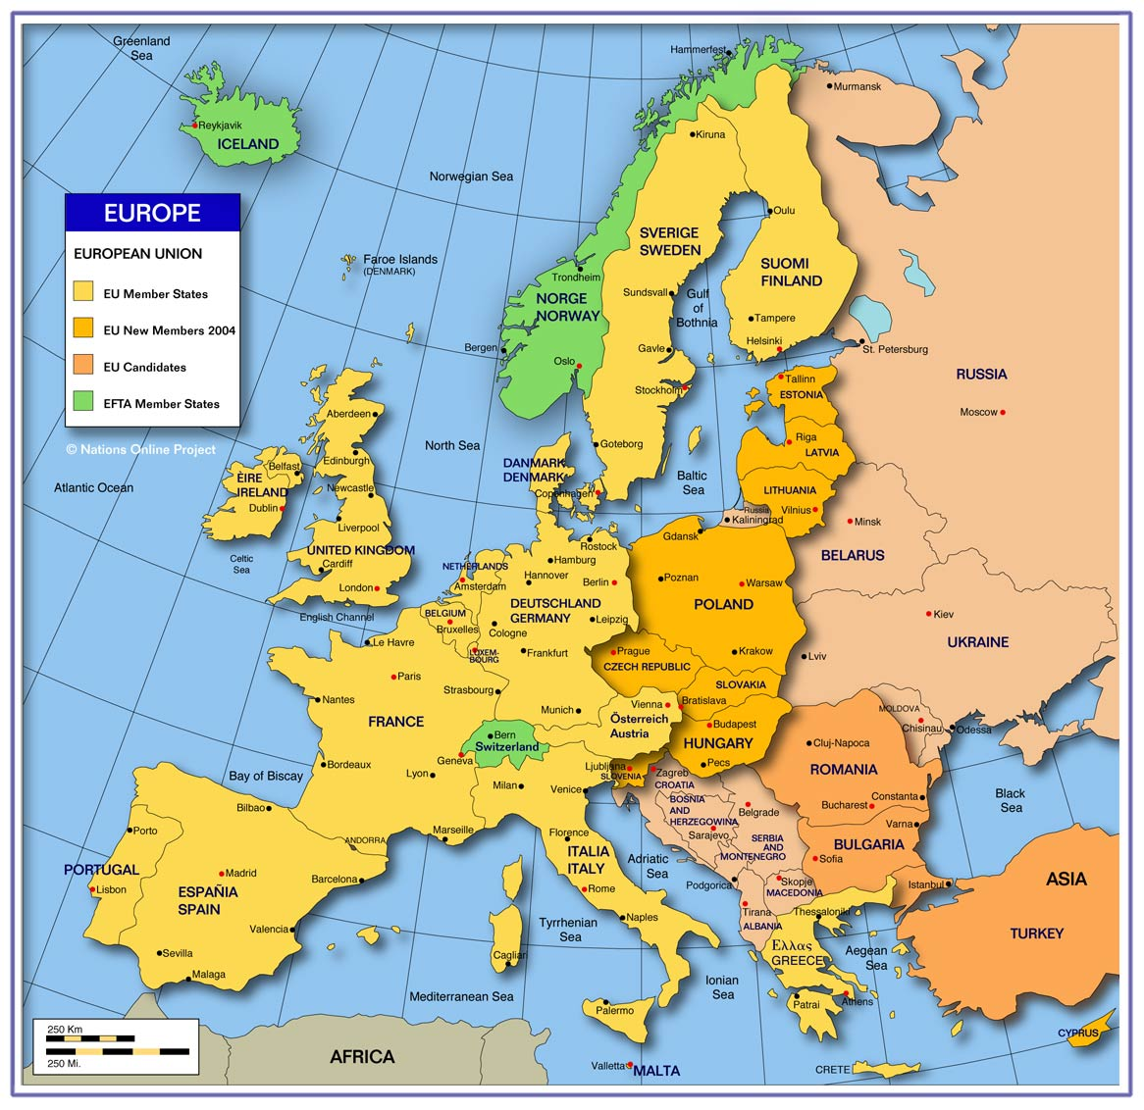

Table 1: Political Map of Europe

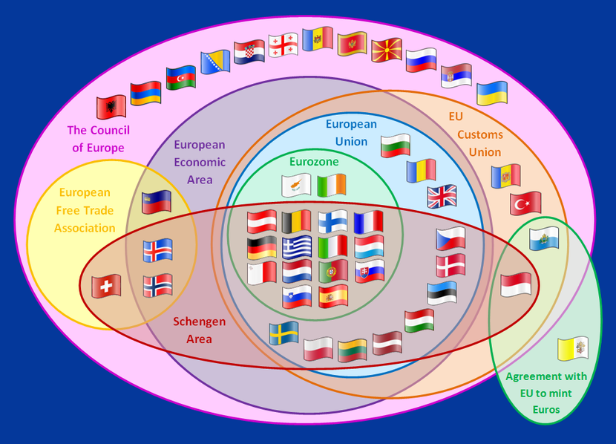

Table 2: Economic Map of Europe
Partnership Profile

This inchoate Leonardo partnership is atypical of the business support arrangements across Europe. None of the members have participated in a European project together before. The major variation within BSPCP is the size and scope of each organisation and whether is supports all sectors in its nation’s economy or just one or two.

Table 3: Partner Employee Profile

As can be seen by the chart above all of the organisations would be defined as small, using European bench marks, with the one exception which is a medium size business; the University being large. This typifies the profession as a low volume high specification business.

This chart shows that the overwhelming majority of partners operate within the not for profit sector, with public sector backing and funding. The private sector is not represented within this project and does not feature significantly in the business support sector across the EU.

Table 4: Partners Sector
General Description

Each partner brings a distinctive description of their operation to the project. As can be seen from the graph below there is a common theme to all the partners: the knowledge and the skills development of individuals; increasing economic activity in addition to the obvious involvement in business support.

Specialisms’

The Partnership, between all the members, encompasses all of the principal business support specialisms; as can be seen from the following chart:

Table 5. Partners Specialisms

This span of specialisms enables the partnership to speak with authority on the Business Support Profession. Collected together within the partnership are public sector workers deliberating in an objective manner whilst the remainder are practitioners from a not-for-profit perspective. This profile gives the research activity and findings legitimacy and validity.

Partnership Role

Each of the partners has a clear primary responsibility within the project; plus a secondary role.

 | Partner
Role | SW | EMC | CDU | IBE | CECA | BES | BCU
Managing partnership
Exchange of experience
Coordination of Benchmarking
Develop the Qualification Matrix
Evaluation
Dissemination
Research

Table 6: Partnership Role

Key Skills and Expertise
When joining the partnership the self elected members offered a range of skills and experience that is vital to the project. The self experienced skills and experience that are embedded within the partnership looks like this:

 | Skills and Experience
 | Management | Education and  Training | EU Projects | Research
Belgium
Bulgaria
Norway
Slovenia
Spain
UK

Table 7: Partners Skills & Experience

Each of the partners has a single lead staff member representing their parent organisation. These single lead members are supported by up to four other staff members from their host organisation. No partner has a trainee as a member of its mobility team.

All partner staff status is supported by their qualification to participate in the project. This qualification is either by the prior achievement of a recognised education award or by significant experience in the business support profession.

There does not exist a map of the qualifying status for the profession of business support therefore benchmarking the partners against a set of recognisable standards is not possible. This is of cause one of the principle reason why the partnership was created. Emerging out of the partnership – and beyond – should be a recognisable benchmark set of standards to measure the profession, at least across Europe.

Knowledge Gathering
A cornerstone of project activity was an exchange of experience event in each of the member’s state/organisation. These six events provided the partnership with considerable insight into the business support activity operating within the public realm. At each event typically would receive presentation from experts in the host nation and an examination of the business support architecture. This enabled the research to have a qualitative and textural feel to its work; reflected in the findings later in this report.

Methodologies
Methodology refers to the overall approach to the research process, from the theoretical underpinning to the collection and analysis of the data. Due to the nature of this piece of research, qualitative methodology has been adopted which consists of a minor literature review and action research. Primary survey action research was conducted within the partnership organisations that captured their national business support architecture. A full evaluation of the methods used is below. This includes a narrative on the design and usage of the variety of methods employed in the study. This section confides itself to a brief description of the methods employed and the research cohorts.

Research Design
The research design needed a mix of quantitative and a qualitative approach, as it provides a more ‘real’ basis for analysis and interpretation (Collis and Hussey 2003). From analysis of the choices that would suit a whole range of differing activities over a longitudinal period; the Leonardo project ran from the third quarter of 2009 until the second quarter of 2011.

Five different quantitative design types were available: experimental, survey, longitudinal (not appropriate to this study), case studies and comparative. Some aspects of the study also applied an action research approach to gather both quantitative and qualitative data. The processes that the research utilised entailed applying triangulation to the various methods of studying the phenomena intrinsic to business support professional. Birmingham City Business School applies a continuously reflective evaluation of actions and this project continued this process during this study; to action research elements and uses an adaptive approach.

The Pan European Business Support Agency Survey research comprised a comprehensive questionnaire covering the three platforms of data utilised to capture the range and extent of agency services. The sample was not randomly chosen (usual in probability surveying) instead non-probability cases were selected by the City of Oslo Government Agency for Business Development. Using online data survey QuestBack eksport software and self-completing participation.

The secondary data collected was to enhance the focus of the research topic, develop and support it (Collis and Hussey 2003). A literature review was conducted from books, articles in journals, magazines and newspapers, reports, conference papers, published statistics, the Internet, electronic databases and other relevant documents. This secondary research had a singular purpose: to seek to establish a definition of business support professionals and the current articulation for business support terminology. The secondary data facilitated a comparison between the primary data collected to place the findings within a more general context to ‘triangulate’ findings (Saunders et al 2003).

Our last design type embodied the logic of comparison so that we could understand the economic and societal phenomenon better when they are compared with two or more contrasting national positions. The data was classified into meaningful categories that could be compared to establish the nature and degree of association between them (Baker 2003), to check for patterns and themes, and to recognise the relationships and reach conclusive findings (Saunders et al 2003). The obstacle of this entire procedure was that the setting up of the templates, transcribing, analysing, and recording was very time-consuming; with now trial sampling possible – it was a one hit process.

Questionnaires
A template for assessing questionnaire was used to gain information from the representing sector business support group who were participating in the project. The questions were simple, straightforward questions that could be easily responded to using own source knowledge or a restricted Lickert Scale of three points. This is an attitude measurement tool used in research, where, in place of a numerical scale for answers, answers are given on a scale ranging from complete agreement on one side to complete disagreement on the other side, with no opinion in the middle. After the questionnaire was completed, each item may be analysed separately or item responses may be summed to create a score for a group of items. Three groups of interrogative questions were framed into positive affirmative language asking for details of their: business profile, support services and coverage of their operation. Each group asked closed questions, of predetermined items, with the option of an open ended addition to the group sets.

The answers are all analysed below in the findings section. Mostly the answers have a group score with additional narrative from the open ended responses.

Evaluation of the Methodology
“Action research is simply a form of self-reflective enquiry undertaken by participants in social situations in order to improve the rationality and justice of their own practices, their understanding of these practices, and the situations in which the practices are carried out” (Carr and Kemmis, 1986:162). In this case, the BCU project team sought to reflect upon the insights achieved through various ‘iterations’ of research tools and techniques in order to develop a rationale for the ‘emergent’ approach. The approach was based on Kurt Lewin’s spiral of steps “each of which is composed of a circle of planning, action and fact-finding about the result of the action” (Lewin 1948). The circle began with identifying an initial idea or proposal, thinking through that idea carefully (given the means and resources available) planning a way forward, taking action steps, evaluating, amending the plan if necessary and taking subsequent action steps to implement new ways forward.

The second objective of the evolving approach towards capturing the dynamics and complexities of business support development, in a way that could be used by policy makers to guide the development decisions and actions, created a further hallmark of the action research process: cooperative inquiry. Heron (1996) noted that the cooperative inquiry approach towards action research “is a form of participative, person-centred inquiry which does research with people not on them or about them”.

Business Support Agencies in the EU & EFF

What is the Business Support Sector?

Definitions of terms and activity are always desired without necessarily have a universally accepted answer; the need to articulate through labelling. Business Support is a phrase in common usage that often defines labelling. For this study business support is defined as any activity that supports the creation and survival of businesses, increases SME profitability and assists business development and growth. The Sector will in this definition incorporate information, advice, training and consultancy on business’ start-up, growth and development.

Beyond that definition the professional practitioners are not easily surrounded by a boundary fence marked “business support sector”. It demonstrably exists as a separate activity sector as defined by classification issued by the Statistical Office of the European Communities (Eurostat) and entitled Nomenclature générale des activités économiques dans les Communautés européennes, usually abbreviated to NACE.

Geographical Coverage

Each of the partners maintains a register (in various forms and extent) of Business Support agencies within their territorial area. These agencies were invited by the partner to participate in filling in an online questionnaire. The response from those invited varied from very high to minimal in Bulgaria (this later due to the shortage of agencies to survey) and the geographical coverage is displayed in the graph below. In total the number of questionnaires completed online was one hundred and eighty six (186); represented by these quantities by country. This chart indicates graphically the differences between the size and extent of business support across the EU & EFF. The UK numbers are from the West Midlands Region only; representing approximately eight million populations. This brings an element of parity to the comparative country sizes; but does not overcome the fact that the national size varies from two to seventy million populations.

Table 8: Geographical Coverage of Responding Business Support Agents

Profile of Business Support Agencies

Each participating agency disclosed their business details to enable verification. The one hundred and eighty six respondents were made up of individual professionals who represent an agency. For the purposes of this report all are referred to as agencies for shorthand. The survey profiled the agencies and the first data set was to establish what they did as the principal activities; giving these results:

Table 9: Type of Business Support Offered

This gives a picture of a broad range of business support with the only surprise was the lack of marketing and legal formation advice – given its importance to new businesses. That with the need for further training support (commented upon further below) should be the areas for future investment.

The grouped answers are all scored in the table above; giving an imagistic representation of the aggregate business support professionals’ services. Additional comments give a broader narrative – in the support professionals own words – and illuminate the findings. Many comment upon their relationship to other actors and the role of Innovation Norway. These comments are indicative of the role professionals’ play:
- “A door-opener and first contact for the entrepreneur...”
- “Through ‘Springboard’ we draw the expertise the entrepreneur needs from the member network”.
- “We have a separate policies aimed at young people and is a low-threshold [programme]. Ungdommene får veiledning og økonomisk The young people receive guidance and financial støtte. Support... Hjelp til å lage forretningsplan Help to create a business plan”
- “As a County Council we are responsible for establishing training, [for] people with a business idea, [to] can get more or less free training vedr flere av temaene nevnt ovenfor samt få klarhet i om han eller hun har de rette gründer egenskaper.[delivering] several ... topics ... and to clarify whether he or she has the right entrepreneurial qualities.”
- “Establishing [a] mentor base for entrepreneurs”. Opplegget vil fra nytt år bli mer
Connecting the two strands together produces a vibrant picture of business support professionals delivering a service. None of the business support services are regulated but are operating with some standards and values. These later matters are reflected upon in the later reports of the partnership. A Benchmark taxonomy that will be produced by the partnership will provide an operational framework for these business support professionals.

Next was to identify the client group or groups that the support professionals assist. Of the choices available to gather the data the survey avoided any socio-economic classification and opted for a generalist approach. The agencies were asked to state simply if they worked with different classifications of clients on a yes or no basis:

Table 10: Who are the Customers?

Customers of Business Support Agencies are characterised by their inability to commence trading without some form of support to trade, but do have the behavioural tendencies of the entrepreneur. As can be clearly seen from the chart above they mostly deliver the business start-up process, but are selective on the status of the individual they provide the service to. Working with potential entrepreneurs is also a more regular feature than most traditional support agencies and is an activity for with one hundred and fifty nine providing this service. Open ended responses to this question provided these individualistic targets:
- “...agriculture and agriculture-based entrepreneurs...”
- “Arbeider opp mot landbruket og aktive gårdbrukere som ønsker å finne flere bein å stå på innen for næringen: gårdsturisme og Working towards agriculture and active farmers who want to find more [of a range of products] in the industry: farm tourism and reiseliv, produksjon og videreforedling av gårdens produkter mm tourism, manufacturing and processing of farm products etc”.
- “[We have] No exceptions - we are so few from before and have not [able to] ‘afford’ to exclude anyone in the first place”.
- “Our customers are mainly the good helpers and only indirectly to the first enterprises. They are followed directly by the municipal hjelpeapparatet og Innovasjon Norge. assistance agencies ...”
- “People on rehabilitation that will go back to work by establishing their own business”
A rich picture of the customers that the business support professionals have to respond to; dependent upon local factors but characterised into the usual formations. Emerging out of the general analysis of customers was a detailed analysis of start-up businesses development.

The survey has tried to establish criteria for assisting start-up proposals, targets for encouraging business development and also how the business support services are funded. In the next three tables and narrative the survey outlines the results on these three matters. It was found that thirty agencies provided support on an open access basis. This means that the business support professional has to deal whatever the person whatever their circumstances. This picture though indicates a concentration not on start-up enterprises but elsewhere.

Table 11: Assisting Start-Up Businesses

Overall a minority of support agencies offer start-up assistance, with less than half of the respondents participating in the activity. One additional comment gives a broader picture than the yes/no answers. “Vi har en temmelig lav terskel siden vi for flere kommuner fungerer som den som skal veilede i det å kun registrere bedrift for eks.We have a rather low threshold since we are more than one municipality is working to guide the company to only register for items. Alle All skal få noe hjelp, men de som har innovasjonsgrad og ambisjoner får mest hjelp. get some help, but those that have innovation and ambition gets the most help.”

A tough access criterion is reported it may answers with these responses being typical:
- “At de stiller med eigne ressurser i prosjektet, enten i form av penger og/eller eigeninnsats. That they [have to] put up their own resources in the project, either in the form of money and / or private efforts. “
- “Normalt å kreve forretningsplan, hvis de ikke har det kan vi bistå med konsulent som hjelper til i den fasen. Normally [access is] requiring a business plan, if they do not have it, we can provide consultancy to help in that phase.”
- “Vi bruker Innovasjon Norges kriterier for hvem som kan få slik bistand, samt lover og regler som gjelder ift næringsetablering We use ... [an NGO’s] ... criteria for who may receive such assistance, as well as laws and regulations that apply in relation to food establishments.”
- “Må kunne presentere ei forretnings mulighet med noe konkret produkt/ tjeneste og være noe konkret på hva kunder en retter seg Must be able to present a business opportunity with a specific product / service and be something specific on what customers are directedinn mot towards.”
- “Vi tilbyr vår bistand til ALLE som tenker tanken om foretaksetablering. We offer our assistance to all of you who think the idea of enterprise creation.”
This approach would resonate with many agencies across Europe. New Venture ideas are plentiful and most business support professionals who meet budding entrepreneurs tell the same stories of plenty being available. But the realisation of the ideas proves to be more difficult to achieve. A whole range of factors will surround a person with a new business venture idea and want to start-up their own business. The received wisdom on the motivation to start a new business has many aspects. The situation of the individual is crucial and these are typically those found in research:
- Losing a job and deciding to start own business as an alternative
- Dissatisfied with current employment
- “I can do it better” as a mind set
- They see a gap in the market
- Due to aspects of the enterprise environment and infrastructure that enable potential entrepreneurs to exploit their skills and opportunities
- Creating new demand
- Finding new ways of exploiting existing markets
- Creating change (order and complacency of existing social and economic systems)

Table 12: Business Development Assistance

A much higher proportion of Support Agencies deliver assistance in developing existing businesses. The reasons are self-evident One additional comment made could give an insight into the reason “The areas ... [that we] answered No does not mean we cannot assist, but that we link into other expertise in the area”. Interpretation of this across the agencies may be that they refer potential new entrepreneurs onto other agencies.

The span of the range is atypical of this type of business support. The most significant area of support is for businesses that face the issue of succession. This Leonard partnership has recorded that this is a recurring trend across Europe – mostly associated with the decline in independent traders due to two factors: sibling reticence to continue in the family business and competition with global enterprise. This last point would indicate greater support for independent traders should be developed to support generational succession.

This next table identifies who is self-evidently paying for the business support services.

Table 13: Who Pays for the Service?
Support Type

After the business support profile the survey went on the attempt to capture a picture of the business support professional delivery. A first finding was to establish the number of Business Incubators operating across partner countries. The survey wanted to establish the range and extent of the business support offered. We asked the professionals to specify: if the used incubation, what were their intervention products and how they measured them, how they provided assistance with the key support of raising finance then details on training and skills development.

Table 14: Who Provides the Incubators

Distribution of Incubation is evenly spread across the states with the exception of Bulgaria that could not identify any. The general picture across all countries is a relatively low level of not-for-profit operation (see recommendations). Otherwise the whole Incubation set-up is epitomised by one extended comment in the questionnaires:Tilbudene gis i hovedsak innenfor næringshager og er finansiert gjennom et partnerskap med bl.a.”Offerings are given primarily in commercial orchards and is funded through a partnership ... Siva og Innovasjon Norge.Vi har We have utviklet en bransjeuavhengig inkubator for ungdom som er et lavterskeltilbud samlokalisert med inkubatormiljøene. developed a business incubator for independent young people who are a low-threshold co-located with the incubator environment.”

Every time a business support professional assists an enterprise, it is usually entitled an intervention (the act of stepping in to give assistance to another party); so that the business will become more efficient or effective.

What are the products that are delivered is the primary issue in consideration of the interventions. The profile given above in table 9 details the thematic support areas provided. In addition to this broad list the list of product areas; these detailed interventions can be categorised as:
- Start-Ups support
- Qualifications for running a business
- Drafting out a Business Plan
- Designing ICT systems
- Marketing/Publicity plan
- Product Design
- Prototypes of products
- Capacity Building
- Finance availability
The measurement of that intervention is usually calculated by the amount of time it takes to deliver the activity. In the next chart these measurements are aggregated:

Table 15: How the Interventions are measured

The standard taxonomy of interventions is to measure the time taken into: hours & days or by need or by the whole activity. The majority are by lapsed time – hour or day. This is not unusual with daily rates as the common lingua franca in consultancy sectors.

Out of box comments in this section indicate a flexible approach to intervention measurement. These demonstrate that flexibility:
- “Etter individuell vurdering kjøper vi av og til veiledning, rådgiving av bedriftskonsulent ol på timebasis.After [an] individual assessment, we buy ... guidance, counselling of business consulting services on an hourly basis. vi forholder oss til det kommunale apparatet og Innovasjon Norge”
- “Innenfor etablerer opplæringa liger det innen 5 timer gratis veiledning.In establishing the education needs [all takes place] ... within 5 hours of free tutoring.”
- “Vurderes i hvert tilfelle.Considered [on need] in each [individual] case. Bla. Browse [by an]a. betalingsevne. ability to pay. Gratis oppstartstimer. Free start-up hours. Betaling etter en bestemt antall timer. Payment for a specific number of hours.”
- “Vi starter vanligvis med et avklaringsmøte på ca 1 t. Næringssjefen måler ikke sin tidsbruk.We usually start with a clarification meeting at about 1 hour. The Commercial Manager does not measure their use of time [on the intervention].”
In the profile section we articulated the business support sector categories. This in hindsight would have benefited from being part of a matrix design of intervention support that could look like this:

 | Products Delivered
Business sector | 1 | 2 | 3 | 4 | 5 | 6 | 7 | 8
Marketing
Business Training
Finance
Legal
Contracting
General Support
Networking
Assessment

Table 16: Products delivered

Key to products:
- Start-Ups support
- Qualifications for running a business
- Drafting out a Business Plan
- Designing ICT systems
- Marketing/Publicity plan
- Product Design
- Prototypes of products
- Capacity Building
- Finance availability

In addition to traditional consultants products it is also important to establish new caching and mentoring and this was the results:

Table 17: Coaching & Mentoring

This indicates that firstly only eighty agencies use contemporary coaching or mentoring methods of assisting the enterprise. Only two nations, Belgium and the UK, had a majority applying these new methods. One of the established nations to use the internationally recognised “Springboard” Coaching System is Norway. This is reflected in the narrative comments made by their respondents; with interesting insights:
- “We use the coaching approach in meetings with entrepreneurs. Grunnkurs The Coaches Training Institute v/Inger Karin Larsen Nerheim. Introduction The Coaches Training Institute v Inger Karin Larsen Nerheim.”
- “[Using the]‘Wheel of Life’,”LØFT” og ”GROW” som metode, men coaching som generell teknikk i forhold til aktuell problemstilling ‘LIFT’ and ‘Grow’ as ... methods, but coaching as a general technique in relation to the relevant issue [not so].”
- “Each entrepreneurial companies that will be eligible to Springboard being coached in the further development of the business plan through workshops and elektronisk kommunikasjon. electronic communication. Våre forretningsutviklere har arbeidserfaringer og egnethet som ikke har gjort det nødvendig med noen Our business developers have work experience and fitness that have necessitated some felles rådgivningsteknikk. common counselling techniques. “
- “Some [staff] are trained coach; others are more self-taught [using] NLP NLP kommunikologi and Communicology .”
This is encouraging on the one hand but needs more investment because of the demonstrably success rates with coaching techniques used versus traditional product driven interventions. Allocated time to the coaching process also varies without being able to find any regular pattern – more research is required to gauge an accurate picture. Most coaching programmes have a negotiable period. The span of time though runs from two weeks to two years in total time. Organisationally this is the main drawback for business support professional that prefer a supply driven model not demand driven. Comments on coaching on and by practitioners demonstrate its usefulness:
- viktigst er ærlighet og ansvarliggjøring.”Most important is honesty and accountability. “
- En må i tillegg benytte egen erfaring og stille gode spørsmål som kan være med på å skape tillit, gode tankeprosesser, og få fokus på”One must also use their own experience and asking good questions that can help to build confidence, good thought processes, and few focus onde områdene som er utfordringen. the areas that is the challenge.”
- Utfordringen er å finne den riktige matchen mellom etablerer og mentor.”The challenge is to find the right match between establish and mentor.”
- Spesielt nyttig for å forankre og kvalitetssikre mål / visjon, og for å løse opp i mulige hindre for måloppnåelse.”Especially useful for anchoring and quality of goals / vision, and to resolve potential obstacles to goal attainment.”
- Coaching et godt redskap til å la kunden få vurdert og avklart levedyktighet av sin forretnings idé.”Coaching a good tool to let the customer reviewed and clarified the viability of their business idea.”
The main help from all business support professional is with finance and helping raise investments into the business. Substantial numbers of support professionals help with the financing side of business support. The table below records the distribution of the help; with financial advice in the minority due to the liability consequences of providing misadvise to a client. The remainder are high relatively intervention rates.

Table 18: Do the Agencies Help Obtain Finance

Some agencies also attempted to describe the experience and these are some of their commentaries:
- “Vi videreformidler kontakt med finansielle miljøer og virkemiddel apparat, er behjelpelig med å se på planer, budsjett og finansieringsplanWe will forward contact [into] financial communities and funding agencies, [we] can help you to look at the plans, budget and financing planog komme med innspill. and provide input.”
- Kopling til riktige miljø som kan hjelpe til med finansiering, søknader osv”Connection to the appropriate environment that can help with funding applications, etc. “
- “Our leading role in this context is to ensure the quality of business plan budgets and create meeting points between entrepreneurs andkapitalmiljøer. capital environments.”
These give substance to the activity and place the success in understanding and accessing into mainstream financial establishments – the networks operating between trusted parties.

Sixty percent of the agencies who responded regularly offer training programmes to their clients. The transfer of business skills from the experienced to the inexperienced is at the heart of business support. It has more rules and regulation than business support itself and has a regular beat of routines that make it attractive to business creation and development. What you deliver in the way of training will depend upon a number of factors:
- Capacity
- Accreditation
- Economic sector specialism
- Resources required
- Expertise of the staff
This then gives a picture of the quality of training, by type, that is delivered in the table below. The largest training programmes are Entrepreneurship with sixty percent of firms delivering this type – not surprising given the customers. What is surprising is the low level of vocational training – more survey work on the customer profile is needed to explain this pattern.

Table 19: The Categories of Training Delivered

The final opened ended commentary is on this section. Details of vocational and technical courses were asked for and this is indicative commentary:
- Teknisk utdanning kan bli aktuelt i interkommunalt samarbeid.”Technical education can be relevant in inter-municipal cooperation.”
- Organisert gjennom en egen utdanningsfunksjon som tilbyr videreutdanning i samarbeid med eksterne samarbeidspartnere innen”Organised through a special education component that offers continuing education in collaboration with external partners inaktuelle områder (ingeniør, økonomi, helse, ledelse) relevant areas (engineering, economics, health, governance).”
- Gjennom Ungt Entreprenørskap sine satsinger tilbyr vil kurs til lærere i utdanning, og til elev og studentbedrifter.”Through Young Enterprise's efforts to offer courses to teachers in education, and student and student businesses.”
- “Different types of certification, welding, hot work, truck routing, overhead crane, etc.”
- Vi har ansvar for ca.”We are responsible for approx40 lærlinger innen bygg og mekaniske fag i egne opplæringskontorer 40 apprentices in the building and mechanical trades in special education offices.”
Finally the mode of training delivery was surveyed. Three different options were given to delineate the training offer. The programme could be delivered on a full time basis, a part time basis or one were one module at a time is undertaken.

The results are these. The encouraging aspects are the use of part time and modular training – so useful to entrepreneurs who are also trying to undertake the business work at the same time.

Table 20: How is training delivered

Coverage of the Support

As a final picture we found out what geographical area the typical business support agency would cover – in terms of its client constituency.

Table 21: Where the Business Support is delivered

Where is the business support delivered and how much geographical spread does an agency have. In table 21 the answers are clear: local and regional (county) are the optimised organisational units of delivery.

This is in keeping with trends elsewhere that local is trusted and accountable. A system of subsidiary is alive in the business support professional.

Conclusions and Further Recommendations

After consideration of the complete research effort and analysis we are able to derive a series of summative conclusions; on the business support structure in Europe. An inconsistency of business support and purpose remains ipso facto the most dominant feature of the service and that it is abundantly present in all Counties. Ideas for businesses are a plenty but the realisation of the ideas into a real opportunity proves to be more difficult to achieve – without business support being readily available to the entrepreneur.

Emerging from this element of the BSPCP project is the conclusion that business support is a key element of the effective delivery of economic development in all countries; as demonstrated in this survey. Embedding and developing the service is accordant between policy and delivery ambitions. In line with most other nations approach, to the organisation and delivery consultancy work, a supply driven model is delivered. This has the advantage of agencies being able to offer a consistent menu of services to clients, delivered within a recognised quality control framework. This is of cause particularly relevant to the delivery of qualifications and the accreditation process. And this pre-organised product driven service is easy to sell to funders; because it is a known range of products to measure outputs and outcomes against contract targets. In one country those product areas are specified.

It is a system then that delivers to the tried and tested and the certain. It has a track record of proven success in engagement and new start-ups – relative to potential. Within the infrastructure is a very low level of not-for-profit operation, with the majority private providers of public contracts. The social enterprise sector would be of benefit to the whole of the business support agency networks. This also applies to start-up assistance that is a lower priority. The relative low level of coaching is indicative of the tried and tested being the normative value. Coaching techniques are more open-ended in delivery and therefore difficult to pre-pack as a product. The advantages of coaching/mentoring approaches (by all identified research) deliver more significant outcomes and outputs that are sustainable businesses. What has not been measured in this report is the taxonomy of business support itself or a structure for the business support professional. This has been the subject of additional research by the partnership group and is published in a further report.

What the report must conclude is that business support professional are comparable between countries and would benefit from a harmonised approach to their organisation and accreditations – through a European wide recognised system.

In detail we offer these detailed conclusions as an outcome of the research:

CONCLUSIONS

- Europe has a well developed network of business support agencies
- It delivers consistency and measurable services
- Coaching Time & Interventions are low level deliverables
- Standards are consistent without structure
- No integrated system appears to be in place between the various actors
- Provision is at the point of delivery
- Training programmes respond to skills shortages
- The main provision is to existing business to enable future development
- The Third Sector is underutilised

RECOMMENDATIONS

As a Partnership we recommend that the European Union authorities review its excellent offer of business support with a view to improving its efficiency and menu. These should include the adoption of new policy initiatives to quantify and recognise Business Support Professionals. Resulting from this study we recommend the following actions:

- This report be adopted and its conclusions
- Further work be undertaken on these issues:
- Product delivery matrix design of intervention be created
- Enterprise Coaching methods be increased, particularly in start-up support
- Have a business support taxonomy
- Policy development to embed the business support practice
- Priorities for investment be developed
- An accreditation process needs to be developed and adopted
- A set of Business Support standards should be established
- Social Enterprises could be more universally applied to the sector

Participating Organisations:

Business Support Professionals

European Business Support Providers Survey: results from six countries, mapping what they do, where and how.

© BCU 2011

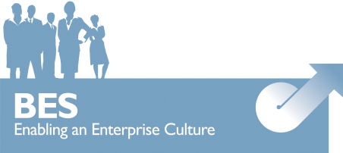

.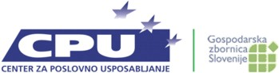

This report has been part funded by:

